RECRUITING YOUNG PEOPLE

An effective recruitment process is important to securing a diverse range of young people in your engagement initiative. Early engagement with partner organisations can help identify young people with relevant experiences

or interests.

# RECRUITMENT STRATEGIES

* **Create youth-friendly recruitment materials**: Use accessible formats like videos, infographics, and social media posts that resonate with young people and are designed for platforms they frequent. When designing youth-friendly materials, consider:

» **Visual engagement**: Use colour and graphic elements to make resources visually engaging.

» **Simple language**: Avoid the resource being text heavy and write the way young people speak.

» **Captions**: Include captions to make your resource accessible.

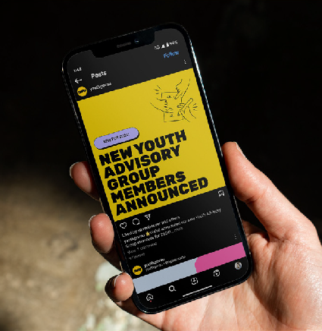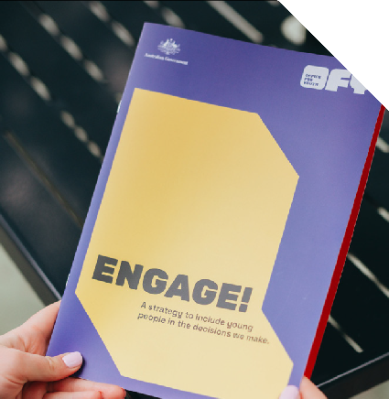

* **Distribute in youth-friendly spaces**: Leverage both online and physical spaces that are popular with young people. For example:

» **Online**: Social media, youth-focused websites, and community forums.

» **Physical**: Youth centres, schools, libraries, community events, shopping centres, religious venues, sports clubs, art and music events, and other places where young people gather.

* **Involve young people in recruitment**: Engage youth in designing and reviewing recruitment materials, advising on distribution channels, and promoting the opportunity through their networks. Their involvement increases authenticity and reach.

**1**

* **Partner with youth organisations**: Collaborate with schools, advocacy groups, and youth advisory networks. This helps ensure a diverse pool of applicants who have strong connections with their communities.
* **Clarify expectations early**: Be transparent about the roles, responsibilities, and benefits of participation. Use project briefs to outline timelines, key tasks, and expected milestones.
* **Plan for parental involvement**: See the “parental engagement checklist” to ensure parental consent and address any potential questions or concerns.

# RECRUITMENT COMMUNICATIONS

Develop a clear position description that provides an overview of the role, including expectations, time commitments, and any requirements. Key information you should include:

* **Role Overview**: Describe the role’s purpose and key contributions to the project.
* **Commitment Details**: Include estimated time commitments (e.g., 4–8 meetings per year, combination of virtual and in-person meetings).
* **Benefits**: List specific benefits, such as skill development, networking opportunities, and

honoraria for participation.

* **How to Apply**: Provide clear instructions on application steps and the submission deadline.

See the ‘*Youth Engagement Opportunity Template*’ for support creating your recruitment communications.

# RESOURCES FOR YOUTH ENGAGEMENT

Agencies may need to prepare or adapt the following resources to support young people once they are engaged:

* **Code of conduct**: Outline expected behaviours, roles, and responsibilities for all participants.
* **Publicity consent forms**: Obtain permission for sharing photos, quotes, or other media involving young people.
* **Volunteer agreements**: Formalise the relationship between young people and the agency, covering responsibilities and expected contributions.
* **Payment forms for honorariums**: Set up payment forms or processes to ensure young people receive any promised honoraria for their contributions.
* **Conflict of interest forms**: Provide forms to ensure transparency and avoid potential

conflicts of interest during the engagement.

Agencies may contact the Office for Youth for examples of these documents, which can serve as

templates or references.

**2**