 

Engage!

A strategy to include young people in the decisions we make.



With the exception of the Commonwealth Coat of Arms, the Australian Government logo, any material protected by a trade mark and where otherwise noted all material presented in this document is provided under a [Creative Commons Attribution 4.0 International](https://creativecommons.org/licenses/by/4.0/) (<https://creativecommons.org/licenses/by/4.0/>) licence.

The details of the relevant licence conditions are available on the Creative Commons website (accessible using the links provided) as is the full legal code for the [CC BY 4.0 International](https://creativecommons.org/licenses/by/4.0/legalcode) (<https://creativecommons.org/licenses/by/4.0/legalcode>).

The document must be attributed as Engage! A strategy to include young people in the decisions we make.

ACKNOWLEDGEMENT OF COUNTRY

The Australian Government acknowledges the Traditional Owners of Country throughout Australia where we gather, live, work and stand. We acknowledge all Traditional Custodians, their Elders past and present, and we pay our respects to their continuing connection to their culture, community, land, sea, water and skies.

We extend this respect to all First Nations young people and acknowledge the importance of First Nations young people having a strong connection to their culture and Country. We also recognise and support the right of First Nations young people to self-determination and to share decision-making with the Australian Government.

Contents

A message from the Minister for Youth 5

A message from the Youth Steering Committee 6

The strategy at a glance 7

Introduction 9

What we did 11

What we heard 13

First Nations young people 16

What we will do 17

Vision 17

Priority 1: We will recognise and listen to young people 17

Priority 2: We will empower young people to advocate and engage with government 19

Priority 3: We will support government to work with young people. 20

Definitions 22

References 23

# A message from the Minister for Youth

This strategy is our vision to ensure that every young person has the opportunity to be included in government decision-making – helping shape the future of our country.

Young people have a lot to offer. We can deliver a better Australia by listening to their valuable insights, perspectives and lived experience. We know that young people are best placed to help us understand the issues they face and help inform policies for the future.

*Engage!* sets out the Australian Government’s vision to ensure all young people across Australia are able to have a say on issues and policies that impact them. It also outlines how the Australian Government will include young people and value their experiences and contributions.

In developing this strategy, we heard from over 4,600 young people to ensure it is focused on the kinds of actions that best and most meaningfully work for young people. We heard a strong desire for the Australian Government to continue working with young people to deliver a better future for everyone.

I would like to acknowledge and thank the amazing members of the Youth Steering Committee – a group of diverse young people from around Australia – for their support to deliver the consultation process and develop this strategy. Their support helped to make this the most ambitious and inclusive series of consultations ever undertaken between the Australian Government and young people.

A special thank you also to the thousands of young people who generously shared their ideas, experiences, and stories at consultations around the country and through our online survey. Your invaluable contributions have helped shape this strategy.

I also acknowledge the youth sector for their ongoing contribution to supporting and empowering young Australians across the country and thank them for sharing their expertise with us.

This strategy marks the beginning of a new chapter in how we work with young people to build a better future for everyone.

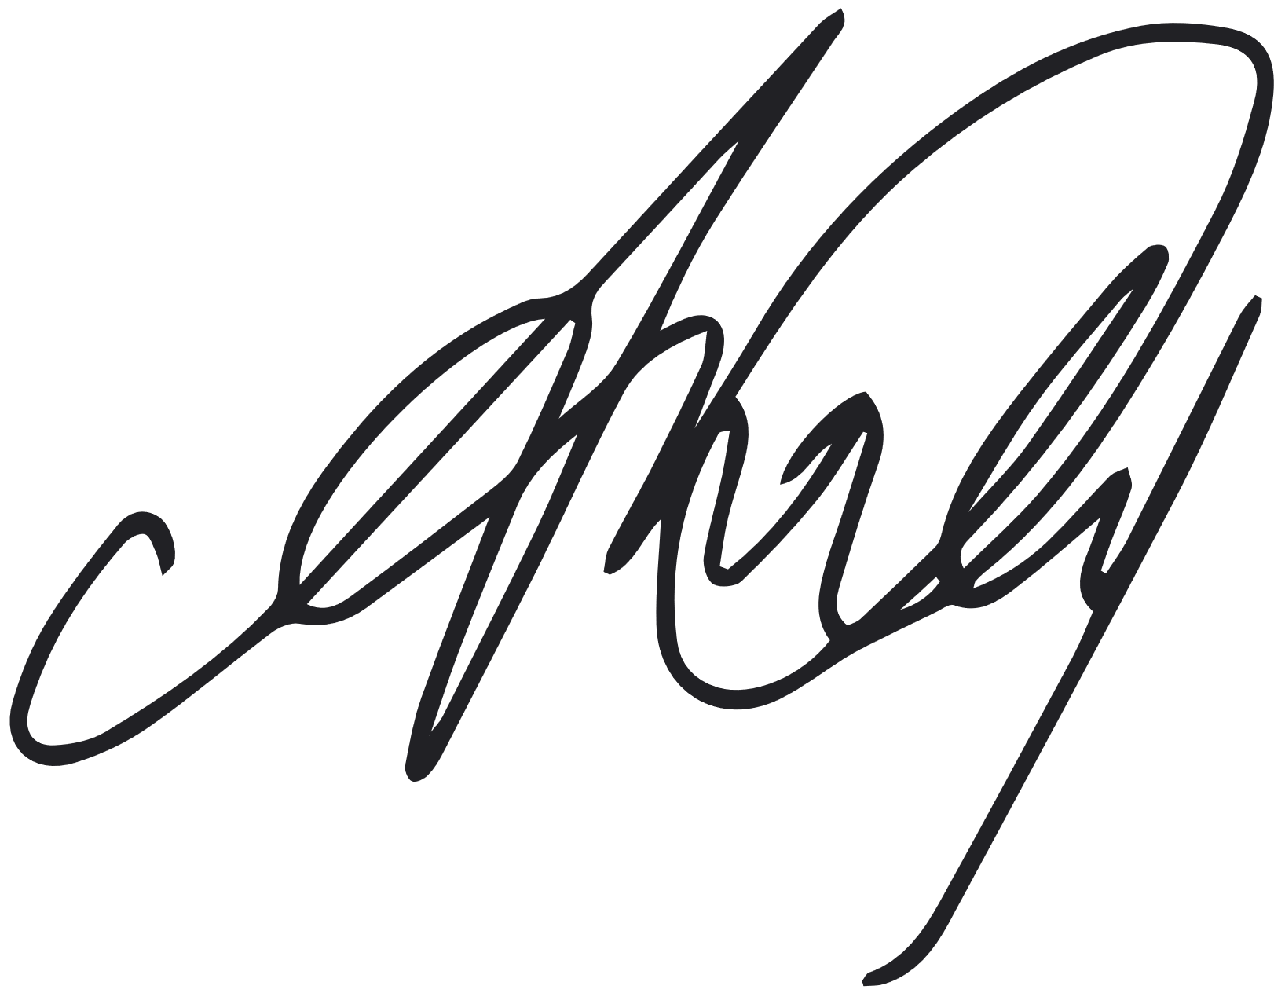

Hon Dr Anne Aly MP  
MINISTER FOR YOUTH

# A message from the Youth Steering Committee

Young people are active community members and are engaged in the events and issues impacting Australia. Since November 2022, we have worked with the Australian Government to design and deliver nationwide consultations to inform the strategy. This strategy identifies what we need when it comes to how government works and engages with young people. We are incredibly grateful for the opportunity to work with the Office for Youth and the Minister for Youth, the Hon Dr Anne Aly MP, and to have our views and experiences listened to and considered.

We strongly believe in the power of young people’s voices and value the importance of guaranteeing young people are heard in decision-making. All our unique and valuable perspectives deserve to be heard. Our hope is that this strategy will encourage the Australian Government to see young people as active participants in decision-making.

This strategy will make possible an ongoing, genuine partnership between young people and the Government. As a whole-of-government strategy, it will ensure that every government department and agency can respond to the needs of young people from across the country. Additionally, this strategy will push for clear and consistent communication between young people and the Government on the issues most important to us. This is because we know that young people’s needs change over time and that not all young people are the same.

We thank the thousands of young people and community members who took part and shared their ideas in our surveys and consultations over the past year. Your contributions have made a meaningful impact in the creation of the strategy. It is the decisions that are made today that will have some of the greatest impacts in the future.

We are excited to see what change this strategy can make for young people, and to see how young people can continue to shape and transform Australia.

MEMBERS

Anargya Djatikusumo

Anhaar Kareem

Billie Gray

Brodie Abrahams

Cindy Liu

Emily Garrett

Eve Currie

Isabel Adams

Isabella Homes

Kiara Petterson

Nayonika Bhattacharya

Oshay Riley

Sebastian Langdon-Macmillan

Taihan Rahman

# The strategy at a glance

VISION

Young people are empowered, valued, and contribute to government decision-making.

PRIORITIES

01  
We will recognise and listen to young people.

02  
We will empower young people to advocate and engage with government.

03  
We will support government to work with young people.

ACTIONS

1.1   
Collaborating with young people.

1.2   
Recognising young people.

2.1   
Connecting with young people.

2.2   
Empowering young people.

3.1   
Listening to young people.

3.2   
Building government capacity.

REPORTING

The Australian Government will publish a monitoring and evaluation report each year on the progress of the strategy.

YOUNG PEOPLE IN AUSTRALIA

There are 4.7 million young people aged 12-25i

5% are Aboriginal and/or Torres Strait Islander

16.3% are born overseas

4.1% are carers

9.3% have disabilityii

2.5% are parents

7.3% are lesbian, gay or bisexualiii

25.9% live in regional and remote areas

45.6% are employed

63.7% are in the education systemiv

‘Young people are diverse, informed and passionate, and want to engage and collaborate with government decision-makers to create a better and brighter future for all.’

Survey response from a young person

# Introduction

Young people in Australia should be empowered, valued and included in the development of policies and programs that impact them.

We know that young people in Australia continue to face increasing challenges, from the ongoing impact of cost of living, to concerns about climate change and experiences of mental ill-health. Young people also feel that they are too often left out of government decisions.v

This youth engagement strategy is a three-year action plan to provide young people aged 12-25 in Australia with more opportunities to contribute to government decision-making.

The Australian Government Office for Youth will lead the implementation of the strategy’s actions and support all Australian Government departments and agencies to build genuine ongoing engagement with young people in Australia.

The strategy will also ensure First Nations young people are empowered to share decision-making with the Australian Government.vi It respects that First Nations young people have the right to be included in decisions, particularly those that impact them and their communities.

We also acknowledge the diverse identities, intersectionality and experiences of young people. The strategy reflects this diversity by providing opportunities for all young people in Australia to be heard, particularly those who are underrepresented in government decision-making.

The Australian Government values young people’s ideas and experiences and will ensure young people are provided with more opportunities to help shape the future of our country.

This strategy is a part of the Government’s new Youth Engagement Model which was set up to help improve engagement between young people and the Australian Government.

The Youth Engagement Model Includes:

### THE OFFICE FOR YOUTH

A team that connects young people and the Australian Government to improve the way that policies and programs are designed for all young people. The Office for Youth also provides opportunities for young people to be included in government decision-making.

### A Youth Steering Committee

A group of young people from different backgrounds who helped shape this new strategy.

### Youth Advisory Groups

Groups of young people who work with Ministers and Australian Government departments and agencies to provide advice on programs and policies affecting young people.

### The Australian Youth Affairs Coalition (AYAC)

The peak body for young people in Australia is receiving ongoing funding to support advocacy for young people.

# What we did

In 2023 we engaged with over 4,600 young people to ask how they would like to be involved in government decision-making.

We connected with young people in the spaces they felt most comfortable and asked them to share their thoughts through online surveys, workshops, focus groups, at community events, festivals and in responses to a discussion paper.

We heard from young people with diverse backgrounds and lived experiences including First Nations young people, LGBTIQ+ young people, young people with disability, refugee and migrant young people, young carers and young people who live in regional, rural and remote areas of Australia. The consultations were guided by our principles when engaging with young people.

Our principles for engaging with young people:

PLANNING

We ensure that engagement is informed and led by young people.

We give young people and their advocates time to prepare and respond.

We are honest about the scope and impact of young people’s contributions.

We collaborate with the youth sector.

DELIVERING

We meet young people in the spaces they feel most comfortable.

We make engagement fun and diverse.

We create accessible, respectful and inclusive spaces.

We are transparent about how information will be used.

FOLLOWING ON

We close the loop with young people and let them know how their contributions were included.

We include young people in evaluation.

CONSULTATIONS

58 consultations with young people and the youth sector.

2,100+ young people and youth sector members joined consultations.

2,500+ survey responses from young people.

34 responses to the discussion paper.

### WHERE WE WENT

The locations where we met with young people and the youth sector are shown on this map. An additional 8 consultations were held online.

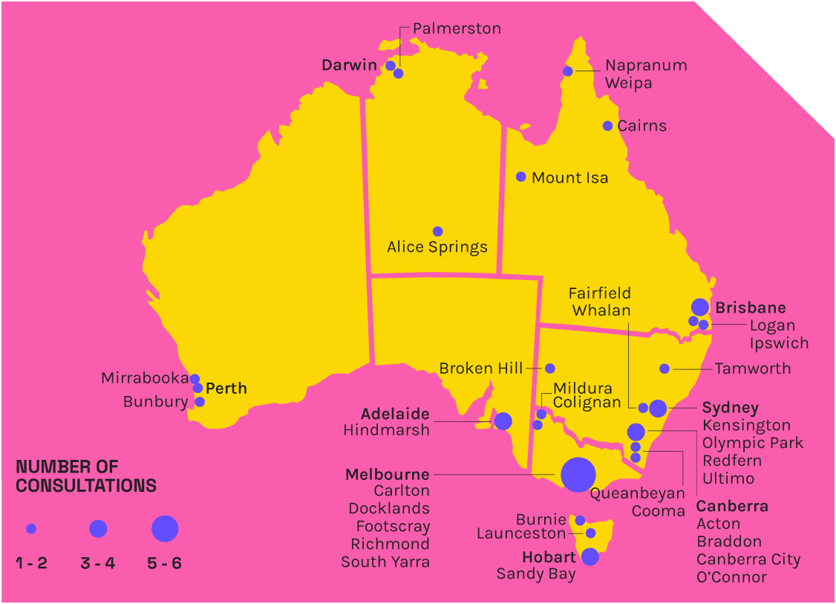

‘Prioritising the voices of underrepresented youth can lead to more inclusive and well-informed policies that address a broader range of people’s needs.’

Young person in a discussion paper response

# What we heard

Through the consultation process we heard about how young people would like to find information, contribute to, and be involved in government decision-making.

78.9% of young people want to be included in government decision-making.

Young people want the government to value their views and to be included in decisions that are important to them.

Young people want to be taken seriously when it comes to decision-making and see their views reflected in policies and programs. This is particularly true when it comes to issues that are most important to them.

Young people want the government to be honest with them about how their ideas might be considered. Young people want to feel assured that there will be meaningful outcomes that reflect their views and experiences. They want the government to see working with them as an important step in decision-making and not just a tick box activity.

MOST IMPORTANT ISSUES FOR YOUNG PEoPLE

55.3% Cost of living

46.1% Mental health

34.7% Climate change and the environment

30.3% Housing affordability, rent and home ownership

29.1% Education and training

Young people want to engage with government in a range of ways.

Young people said that having a variety of ways to get involved in decision-making will enable more voices to be heard. This includes a mix of online, in person, formal and informal opportunities to engage.

Young people also stressed that opportunities to get involved with the Australian Government need to be accessible, safe and supportive.

How young people want to engage with government decision-making

43.3% Filling out a survey

40.3% Events at school, TAFE or university

39.6% Social media

31.7% Youth organisations

30.4% Face-to-face events

‘It is important that the diversity of young people’s voices are being listened to, encouraged, and supported.’

Young person in a discussion paper response

Young people want information shared with them in the spaces where they are.

Young people told us they want to know about what the government is doing for them. Young people would like the government to share information that is easy for them to access and understand. This includes things like:

* How to access government services and support.
* Opportunities for young people around the country.
* Updates about policies that impact them.
* How to get involved in government decision-making.

Young people would like for information to be shared with them in the spaces they use, such as social media. Young people told us a range of ways they would like the government to communicate and share information.

When asked how they would like to hear about what the government is doing, young people said:

68.8% Social media

36.9% News

29.4% Youth organisations

# First Nations young people

The Australian Government recognises and values the traditional knowledge, cultures, and ways of being of First Nations young people, and their connection to Country.

First Nations young people have an important role to play in shaping the future of Australia. Through the National Agreement on Closing the Gap, the Australian Government has committed to working in partnership and sharing decision-making with First Nations people. The National Agreement acknowledges that better outcomes are achieved when First Nations people have a genuine say in the design and delivery of services that affect them.

In our consultations, First Nations communities told us that to get involved in decision-making First Nations young people need to be supported to have a strong cultural identity. We also heard that government needs to ensure that spaces where we engage with First Nations young people are culturally safe.

The strategy will ensure that First Nations young people have more opportunities to connect to culture and Country and be included in government decision-making. By respecting First Nations young peoples’ ways of knowing and doing, we will ensure that engagement processes are genuine and meaningful.

We will do this by ensuring First Nations young people are considered and prioritised in the development and implementation of each of the actions outlined in the strategy. In doing so, we will hope to support and empower First Nations young people to share decision-making with government.

‘The importance of Indigenous youth taking up space in government reaffirms what our Elders and ancestral knowledge systems have taught us about survival on this land. Being able to have our voices amplified allows us to practice self-determination towards our past, present and future.’

Youth Advisory Group member

# What we will do

## Vision

Young people are empowered, valued, and contribute to government decision-making.

## Priority 1: We will recognise and listen to young people

The Youth Engagement Model is already providing young people a formal way to engage with government on the important issues that matter most to them. However, we know that young people want more opportunities to contribute to government decision-making. The Australian Government will provide young people with more platforms to share their views, ideas and experiences with government and the broader community. In doing so, young people from right across the country will continue to help shape the future of Australia and be recognised for their efforts. We are continuing to achieve this priority by recognising and collaborating with young people in ways that value their lived experience.

### Action 1.1 Collaborating with young people

We will run an annual National Youth Forum to provide opportunities for young people from across the country to share ideas, build skills and contribute to government decision-making. This forum will include workshops and discussions on policies and programs that impact young people. We will also host other consultations each year to support the National Youth Forum. This will enable us to connect with young people in the spaces where they are, such as at schools, TAFEs and universities.

We will continue the Youth Advisory Groups that partner young people with an Australian Government department or agency. Youth Advisory Group members work on the development of policies and programs that matter to young people. The focus and membership of the Youth Advisory Groups will change annually and will include a First Nations Youth Advisory Group each year.

We will continue our collaboration with the Youth Steering Committee which will provide advice and support the delivery of this strategy. Youth Steering Committee members will also provide guidance on the development of policies and programs that impact young people.

Case Study from the Youth Advisory Groups

The Youth Advisory Group on Climate Change and COP28 worked with the Department of Climate Change, Energy, the Environment and Water to help shape Australia’s engagement at the 28th Conference of the Parties of the United Nations Framework Convention on Climate Change. Youth Advisory Group members contributed to the design of the Australian Pavilion’s programming and provided advice to the department and Minister for Climate Change and Energy on ways to better engage with young people. A member of the Youth Advisory Group travelled to attend COP28, participating in youth panel events, observing negotiations and networking with counterparts from across the globe.

‘Climate change is a global, intergenerational challenge. While young people stand to lose the most from the impacts of climate change, they are also powerful agents of innovation and change. Engaging directly with young people through the Office for Youth and the Youth Advisory Group model, is a great example of the intergenerational dialogue needed to co-design public policy to achieve a prosperous and low-carbon future for Australia, and the world.’

Department of Climate Change, EnerGy, the Environment and Water

### Action 1.2 RECOGNISING young people

We will establish a National Youth Week to recognise young people’s contributions to their communities in Australia. We will promote the positive contributions of young people and host the National Youth Forum.

We will also provide ongoing funding and support for the Young Australian of the Year Awards. This initiative recognises outstanding young people from around Australia who have made a significant contribution to their communities and country.

### Measuring our progress

Each year we will review our progress on this priority by measuring:

* Percentage of program participants who felt they directly influenced a government policy or program.
* Percentage of young people who report a positive experience at a government event or program.
* Percentage of program participants who feel they are recognised for their contributions in the community.

## Priority 2: We will empower young people to advocate and engage with government

Young people have said it needs to be easier to find information about government programs and services. Young people also want opportunities to build their skills and confidence in advocacy and leadership. The Government is making it easier for young people to find the information they need and we are providing opportunities for them to build their skills to engage with government. Our goal is for young people to feel empowered to access government programs and services and advocate for their views in a range of ways. We will continue to achieve this priority by empowering and connecting with young people.

### Action 2.1 Connecting with young people

We will develop a new digital youth hub and updated social media channels for young people. Through these digital platforms young people will be able to easily connect with government and access the information and support they need. These resources will be accessible with content created and guided by young people.

The digital youth hub and social media channels will highlight information and resources to empower and support young people including:

* How to access services and support.
* What is happening for young people around Australia.
* Where to find information about topics relevant to young people.
* What the Australian Government is doing for young people.
* How to share ideas and engage with the government.

‘Engage with young people in young people’s spaces and on young people’s terms.’

Young person in a discussion paper response

### Action 2.2 EMPOWERING young people

We will provide opportunities for First Nations young people to build their capacity to engage with government. We will achieve this by providing grants to strengthen the capability of First Nations young people in leadership and engagement. This action will support First Nations young people to have a strong cultural identity and empower them to advocate on the issues that matter most to them.

We will also create more opportunities for young people to advocate for their ideas. We will achieve this by providing grants that support young people to advocate and build their leadership skills. These grants will particularly support marginalised young people including rural, regional and remote young people.

### Measuring our progress

Each year we will review our progress on this priority by measuring:

* Percentage of young people who engage with the digital youth hub and social media channels.
* Percentage of young people who were able to access the government information they needed on the digital youth hub.
* Percentage of First Nations young people and underrepresented young people participating in a program who feel more confident to engage with the government.

## Priority 3: We will support government to work with young people.

Young people want government to consider their views and listen to them when making decisions. We are improving the way that government works with young people by building government skills and confidence in youth engagement. This is helping to ensure that young people’s perspectives are regularly being included as an important part of how government develops policies and programs that impact young people. We will continue to achieve this priority by listening to young people and building the capacity of the Australian Government.

### Action 3.1 Listening to young people

We will develop and conduct an annual National Youth Survey. This will allow us to better understand young people’s experiences and ideas while providing a direct way for young people to provide ongoing feedback to government.

We will find out what issues matter most to young people and how they would like to be included in government decision-making. This information will help guide the resources and services offered by the Australian Government. The findings of the survey will also be shared across government to help shape new and improved policies and programs that impact young people.

### Action 3.2 Building government capacity

We will create resources and training materials to build the capacity of the Australian Government to work with young people. This will enable the Australian Government to consider young people in the design of new policies and programs.

These materials will feature information about safe, accessible, and inclusive ways to work with young people. This will ensure the government can better support young people from diverse backgrounds, experiences and identities to contribute to government decision-making.

‘The government should involve young people in decision-making because they are the future and the decisions that are made today affect the Australia of the future.’

Survey response from a young person

The youth engagement resources and training materials will include:

* Toolkits
* Workshops
* Checklists
* Training

### Measuring our progress

Each year we will review our progress on this priority by measuring:

* Percentage of young people who feel that the Australian Government considers the views of young people.
* Percentage of Australian Government departments and agencies that worked with the Office for Youth and felt supported to engage with young people.
* Percentage of the Australian Public Service who feel confident engaging with young people on the development of policy and programs.

# Definitions

| **Term** | **Definition** |
| --- | --- |
| **Accessible** | Making sure everyone has the same opportunities to access services, information, spaces and fully participate in their communities. |
| **Advocacy** | Taking action to support a cause or address an issue that is affecting a person or community. |
| **Agencies and Departments** | Organisations and groups in the Australian Government responsible for different policies and programs. |
| **Decision-making** | The process of making choices about government policies and programs. |
| **Government** | The Australian Government which is the national government of Australia. |
| **Inclusive** | Ensuring everyone is valued and supported to participate, free from discriminatory beliefs, attitudes and practices. |
| **Intersectionality** | This refers to the ways in which all of the different parts of a person’s identity can result in unique challenges and forms of discrimination. |
| **Lived experience** | Personal knowledge about the world gained through direct, first-hand involvement or experience. |
| **LGBTIQ+** | An abbreviation which is used to describe lesbian, gay, bisexual, trans, intersex, queer or any other sexually or gender diverse people. |
| **National Agreement on Closing the Gap** | An Australian Government strategy that aims to reduce disparity between Aboriginal and Torres Strait Islander peoples and non-Indigenous Australians on key health, education and economic opportunity targets. |
| **Policies and programs** | Plans and activities made by the Australian Government to address different issues or provide support to people. |
| **Self-determination** | The fundamental right of people to shape their own lives. |
| **Young people** | Young people are between the ages of 12-25. |
| **Youth sector** | Organisations that provide support to young people and advocate for young people. |

# References

1. Australian Bureau of Statistics, *National, state and territory population,* ABS website, 2023, accessed 21 December 2023.
2. This includes young people aged 15–24. Australian Institute of Health and Welfare, *People with disability in Australia 2022*, AIHW website, 2022, accessed 04 January 2024.
3. This includes young people aged 15–24. There is limited data about the number of LGBTIQ+ young people in Australian Bureau of Statistics (2020), General Social Survey: Summary Results, Australia, ABS Website, accessed 4 January 2024.
4. Australian Bureau of Statistics, *2021 Census of Population and Housing* [TableBuilder], ABS website, 2021, accessed 14 December 2023.
5. Monash Centre for Youth Policy and Education Practice (CYPEP), *The 2023 Australian Youth Barometer,* Monash University, 2023. <https://doi.org/10.26180/24087186.v2>.
6. This strategy uses the term ‘First Nations’ as an overarching term to refer to Aboriginal and Torres Strait Islander peoples. The Office for Youth is committed to ensuring we pay respect to and use the names of the Language, Social, or Nation groups of the young people we are engaging with through our work.

[**YOUTH.gov.au**](https://youth.gov.au)[**@YOUTHgovau**](https://www.facebook.com/Youthgovau/)