WHO’S IN YOUR CIRCLE?



This mapping tool will help you explore the networks and communities you engage with and to discover opportunities for deeper collaboration.

# EXAMPLE 1: IF LINEAR THINKING IS YOUR STYLE….

Using the table below, under each category list the specific organisations and if appropriate the

people within the organisation.

|  |  |  |  |
| --- | --- | --- | --- |
| **CATEGORY** | **CURRENT RELATIONSHIP** | **OPPORTUNITY FOR GROWTH** | **NEXT STEPS** |
| **YOUNG PEOPLE** |  |  |  |
| **SCHOOLS/ EDUCATIONAL INSTITUTIONS** |  |  |  |
| **YOUTH ORGANISATIONS** |  |  |  |
| **COMMUNITY GROUPS** |  |  |  |
| **PARENT BODIES** |  |  |  |
| **OTHER STAKEHOLDERS** |  |  |  |

**1**

# EXAMPLE 2: IF YOU’RE MORE A CREATIVE THINKER….

Draw a large circle in the centre of your screen or piece of paper. This represents your organisation. Branch out from this central circle to smaller circles, to represent existing relationships. Use lines to connect the circles, and different colours to identify gaps or opportunities for growth. You can create this map with:

* **Miro or Canva**: Using online tools for interactive mapping.
* **Paper and Markers**: Create a visual on paper to pin on a wall for team discussions.
* **Sticky Notes**: Write names on sticky notes and move them around a board to represent connections dynamically.

**COMMUNITY**

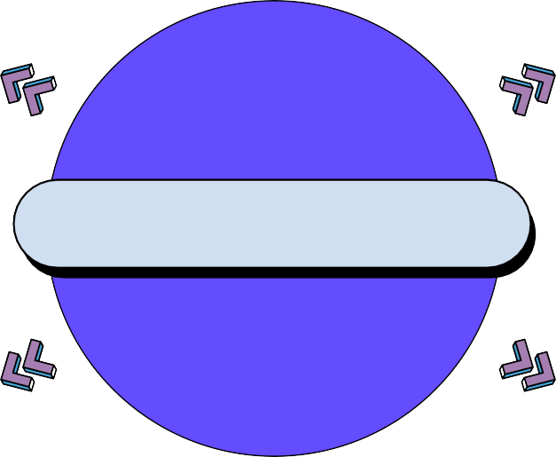

**COMMUNITY COMMUNITY**

**ORGANISATION**

**COMMUNITY COMMUNITY**

**COMMUNITY**

**2**